Software Requirement Specification
Tourism Management System

Name : ShanthanaKrishnan A B S
Ace No : 2074
Date : 13/09/2013

CONTENT

S.No | Title | Page No
1 | Objective | 3
2 | Modules | 3
 | - Login | 3
 | - Registration | 4
 | - Administration | 4
 | - Reservation | 4
 | - Payment | 5
 | - Cancellation | 5
3 | Users | 5
 | - Administrator | 5
 | - Tourist | 5
1. Objective:
Tourism Management System is allowing the tourist to choose the tour package and book the ticket. Since it is the family tour , minimum one and maximun five person can travel per ticket. The users have to register their personal details for creating their account and only registred user are allowed to book the tickets . Administrator can view the tourist ticket and can maintain it in the database.
2. Modules:
  - Login
  - Registration
  - Administration
  - Reservation
  - Payment
  - Cancellation

2.1 Login
In this module contains the login process, the username and password get from the users and check whether authorized user or not. Username and password is case sensitive.Based on the authority the process flow will be changed (Admin or Tourist). Once the login is done the session or log details will be maintained. Only registred user can login in to my application. More than one user cannot have same username.
- Username
username should start with alphabets and end with numbers, no special characters, space allowed and username is case-sensitive . More than one user cannot have same username.
- Password
password should contain alphabets and numbers only and it is case-sensitive
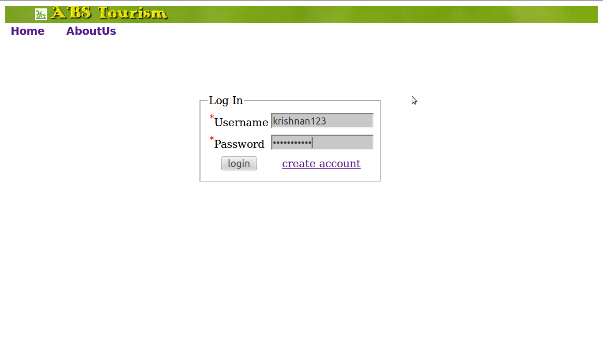
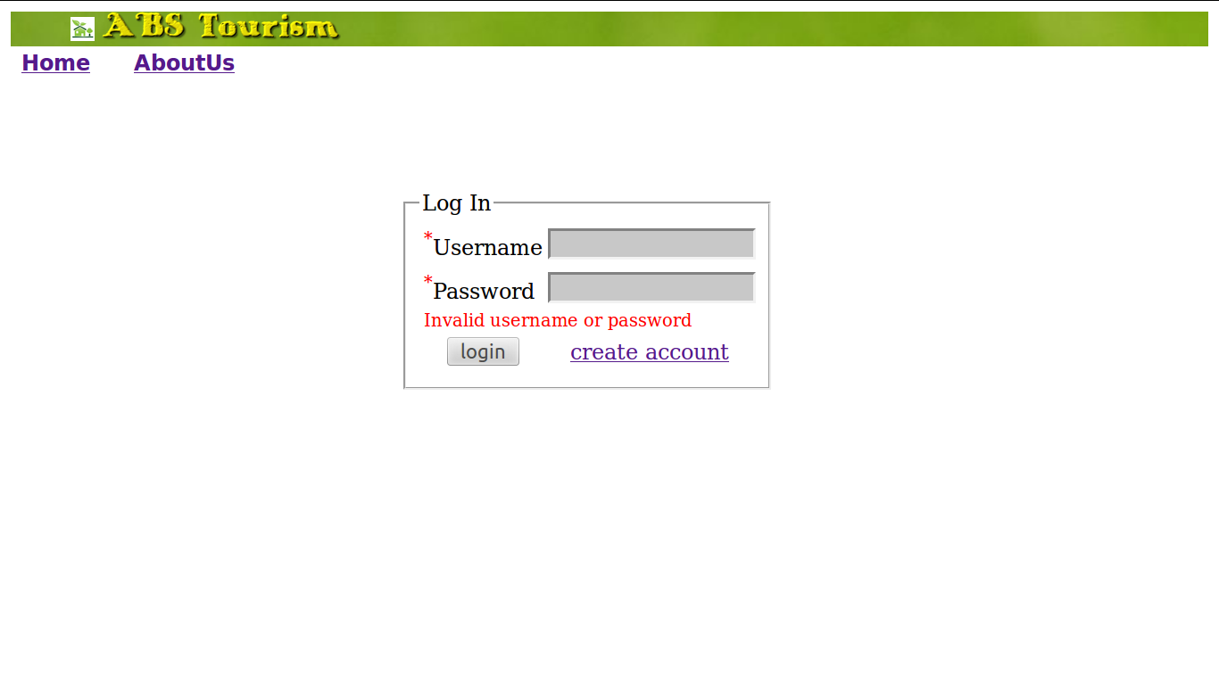
2.2 Registration
In this module the tourist’s personal details are managed. It is mandatory that all the tourist should register before booking the ticket, unregistred tourist cannot login and book the tickets.

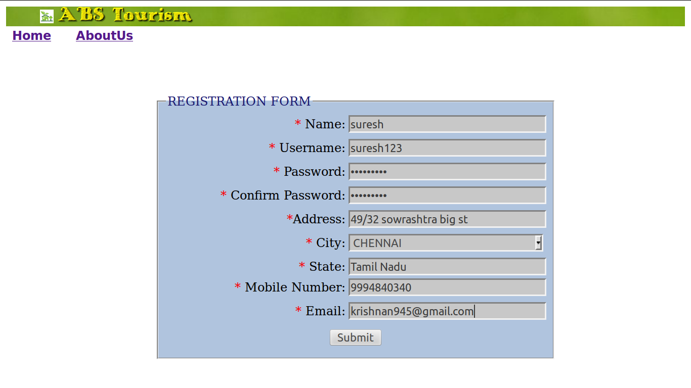
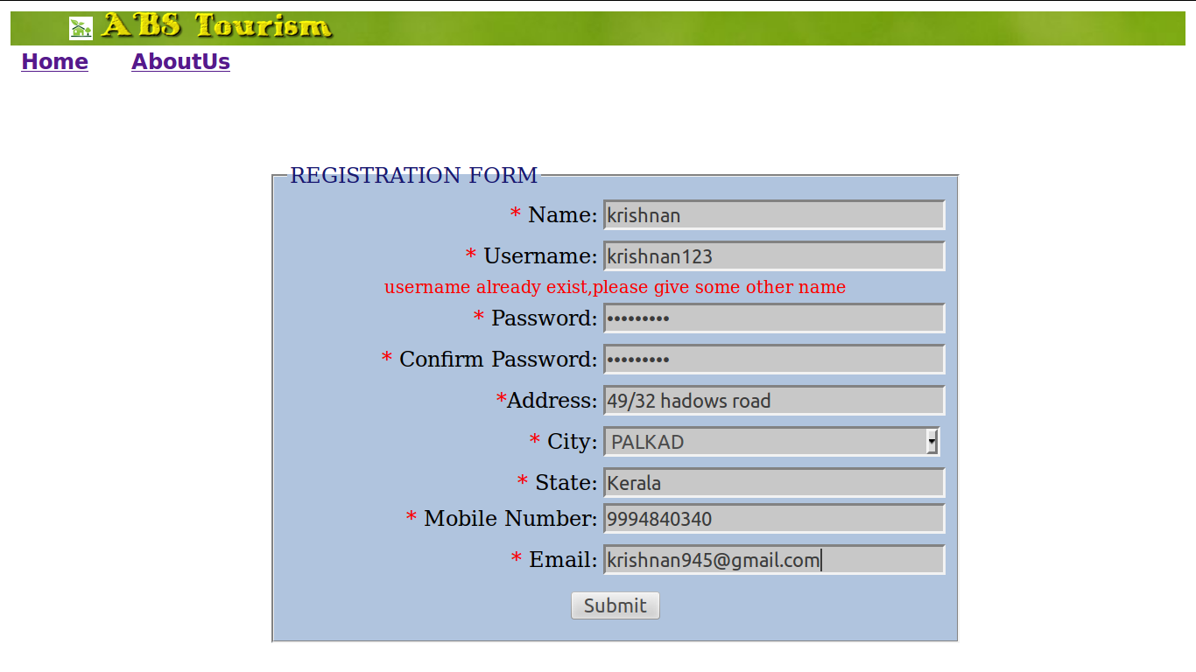

2.3 Administration
In this module describe the administrator functionalities.
- Can view all the tickets booked by the tourist
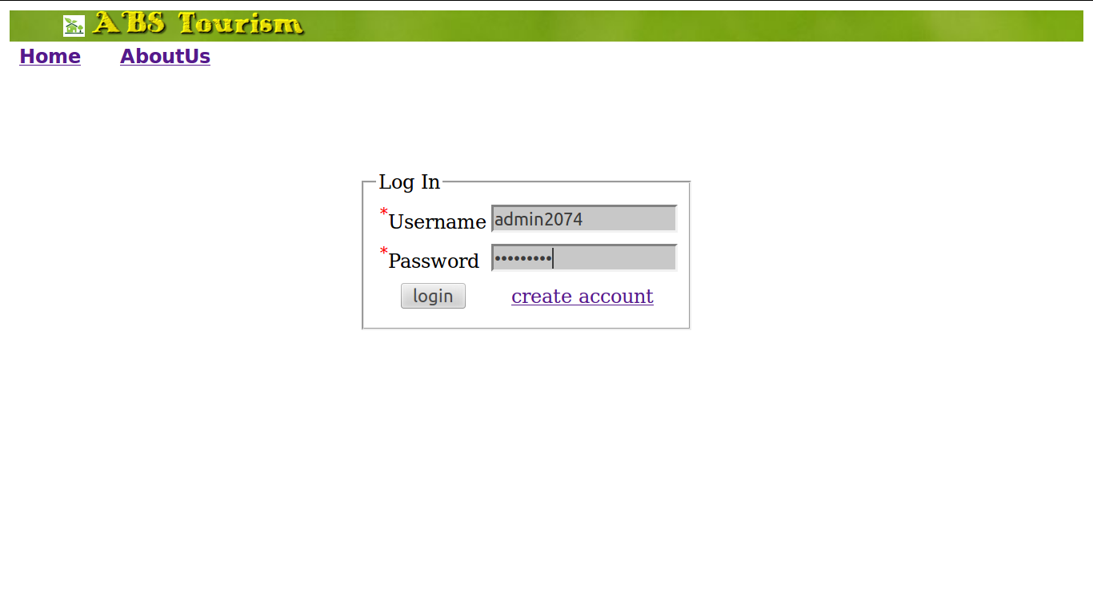

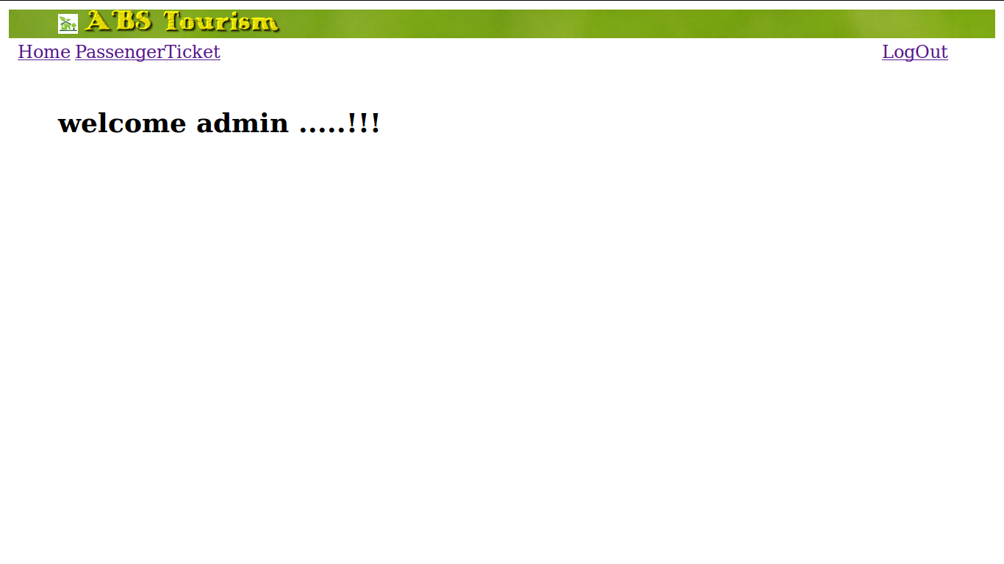

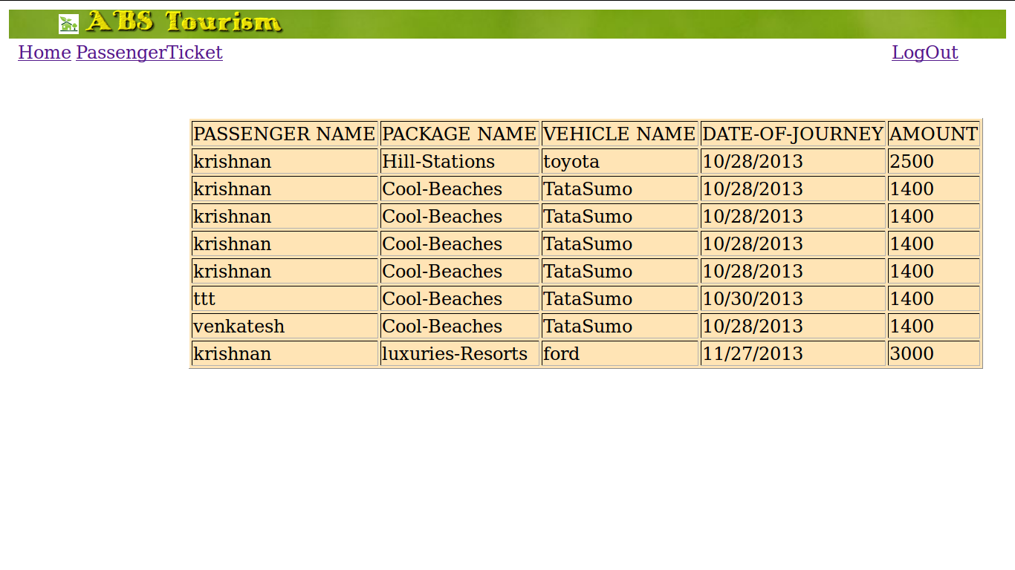

2.4 Reservation
In this module describe the reservation functionalities.
- While choosing the Tour Package tourist need to give his/her date of journey and according to the journey date tour package availability is checked
- If package is not available , the tourist need to select someother package on the same date or change the date of Journey
- Since it is the family package tour minimum one and maximum five members are allowed per ticket . No matters that single person or five person are travelling in a single ticket , tour package cost wont change , remainds same .
- session wont allow the user to stay idle , if the user stay idle for 5 minutes or more , then the session get expired and user is redirected to the login page and user needs to login again
- In a every single day only 10 families are allowed to book the same tour package .
For eg : If 10 families already booked Hill station package on a particular date (31/10/2013), No
other family can book that package on the same date . It ask the tourist to cange the date or package.
- Tourist are allowed to view their booked tickets.
- Both tourist and admin activities are maintained in a log file .
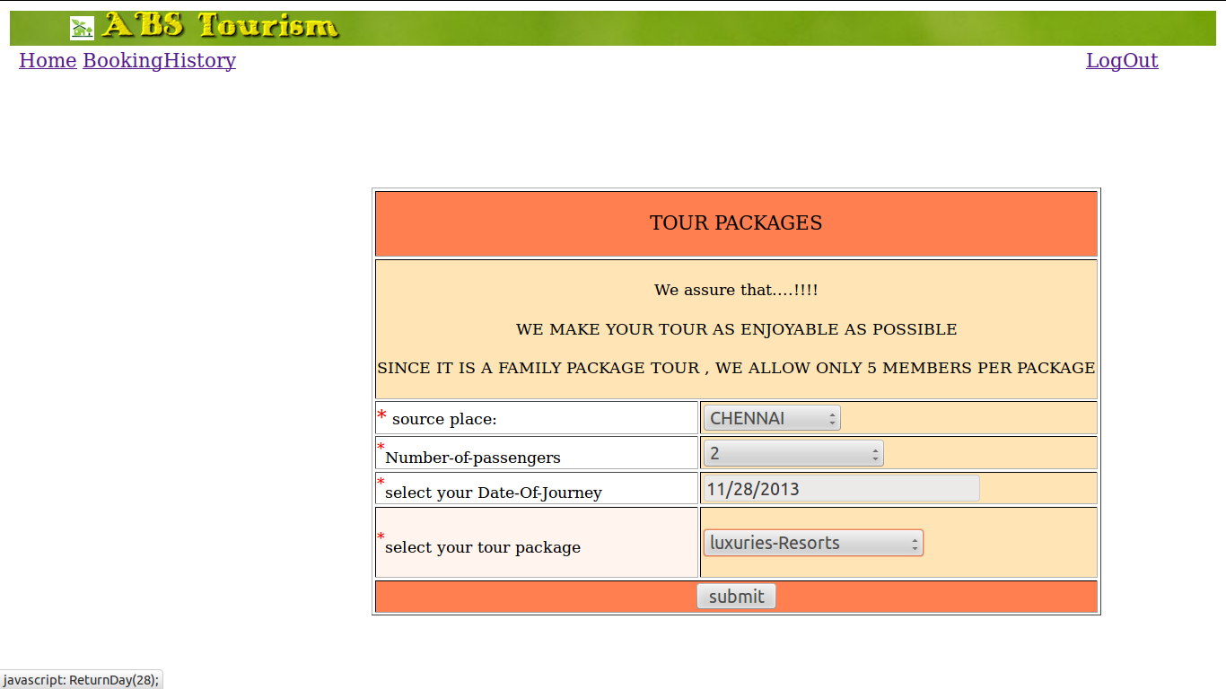

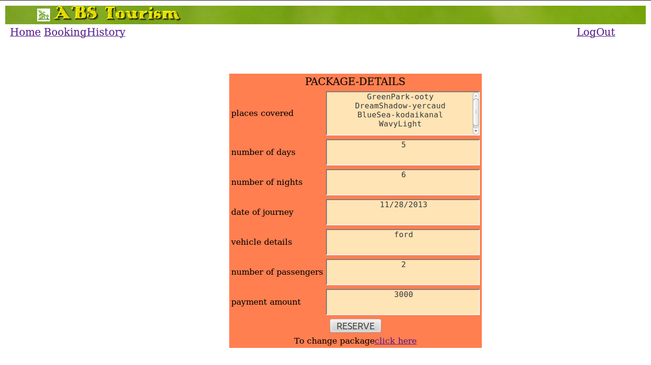
2.5 Payment
The payment processes are done by payment gate way. The credit card validations are done by the luhn algorithm. In this payment comes along with the reservation. Ticket get booked only if the tourist completes the payment process successfully
The following ways are available to pay the amount:
- Credit card
It should contain valid 16 digit , should not contain special characters and alphabets
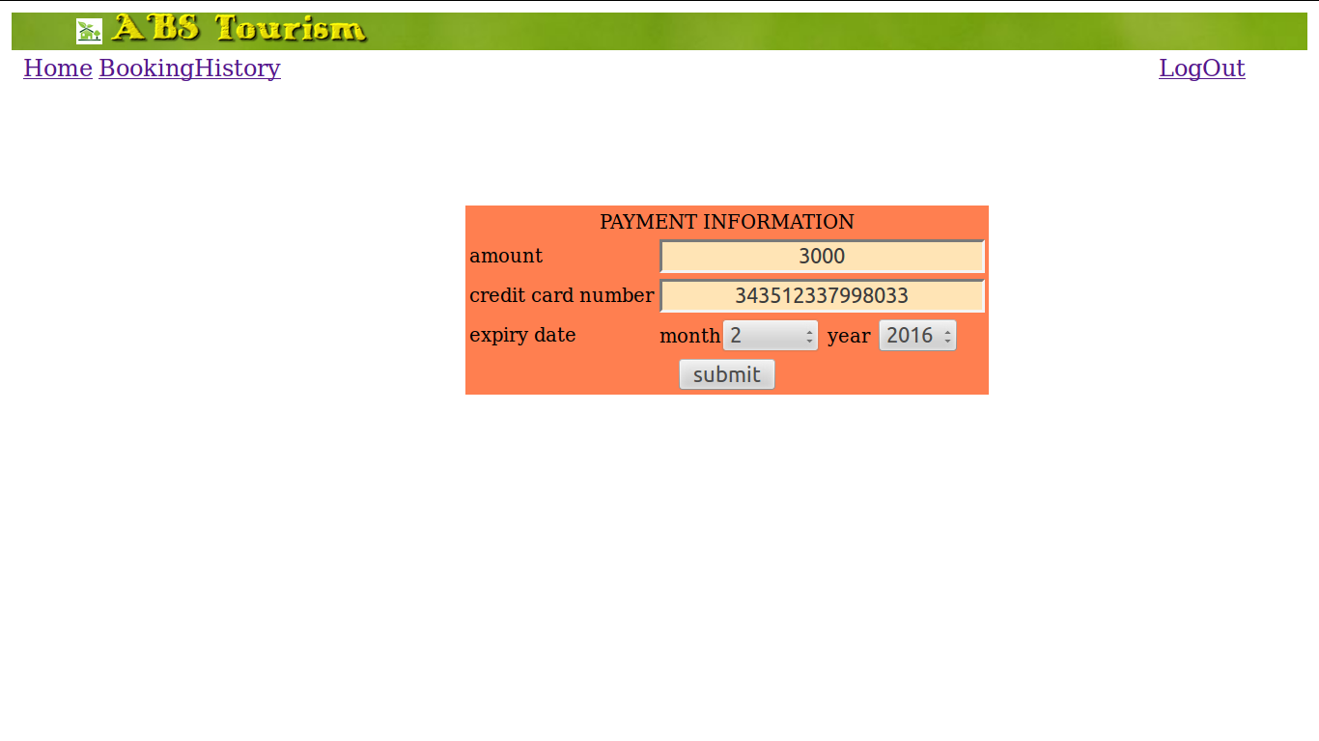

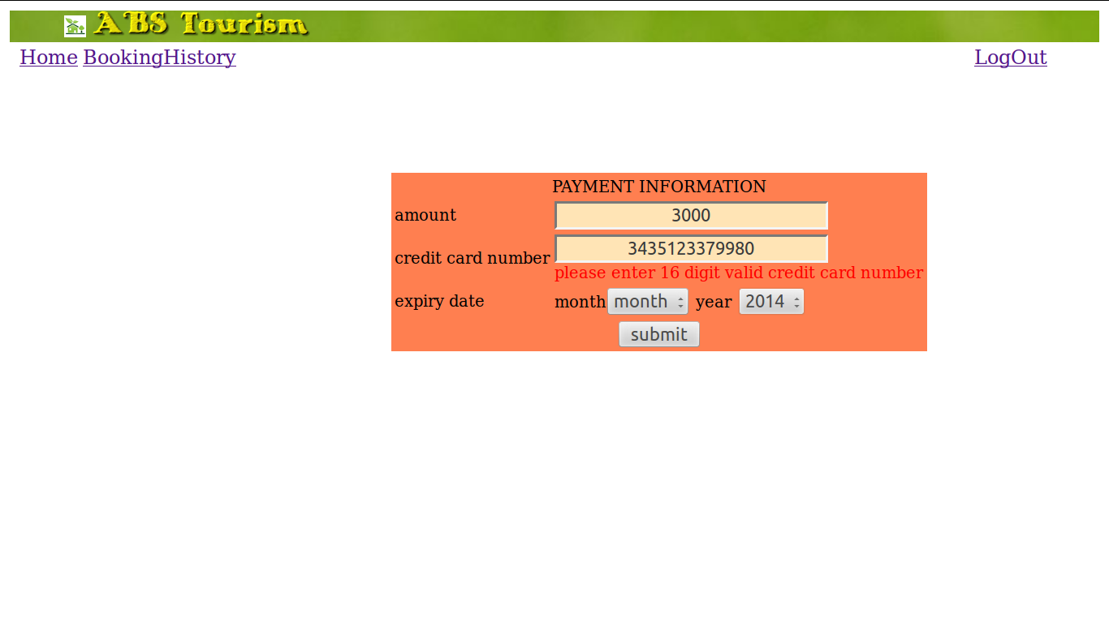

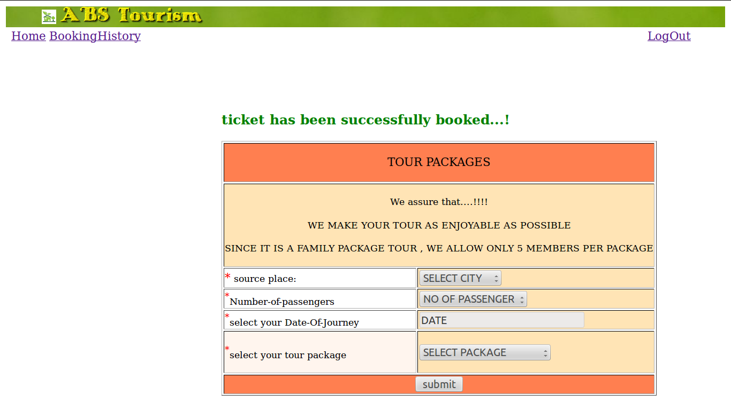

2.6 Cancellation:
The cancellation process is done by matching the regId and ticket Id.
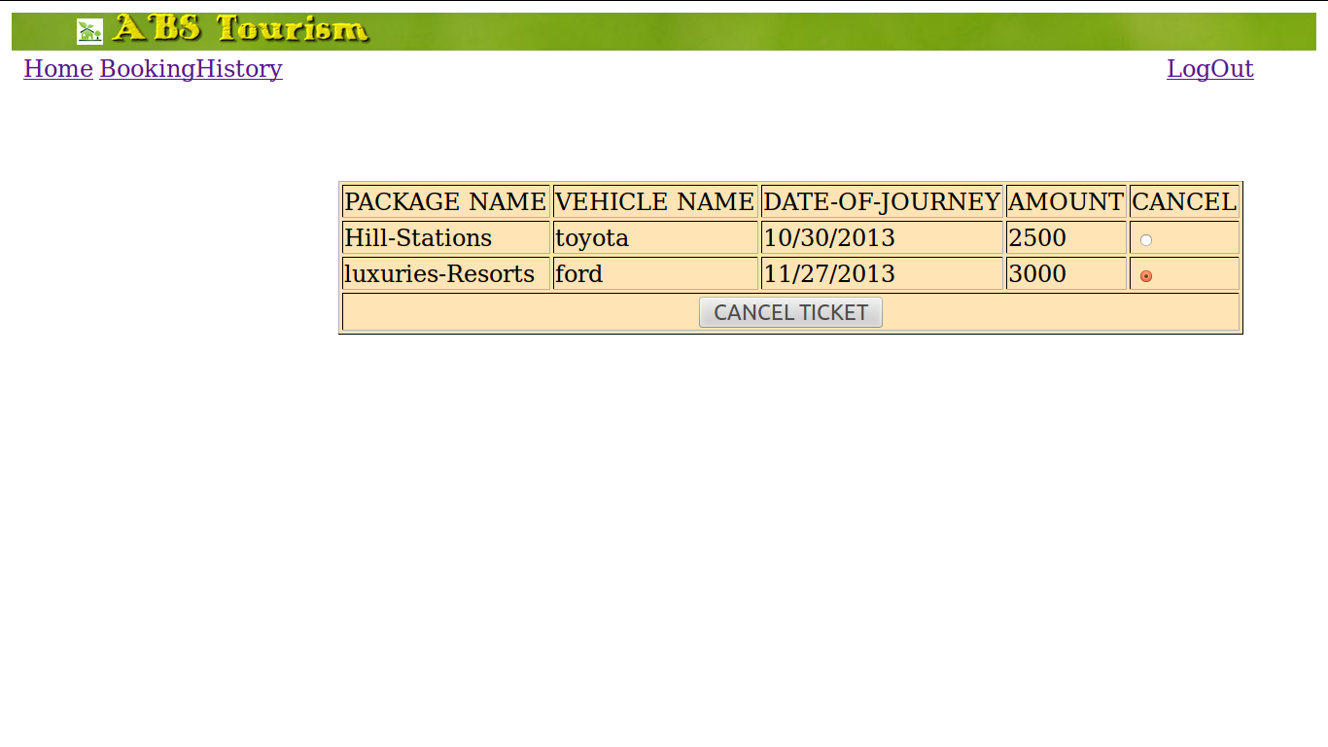

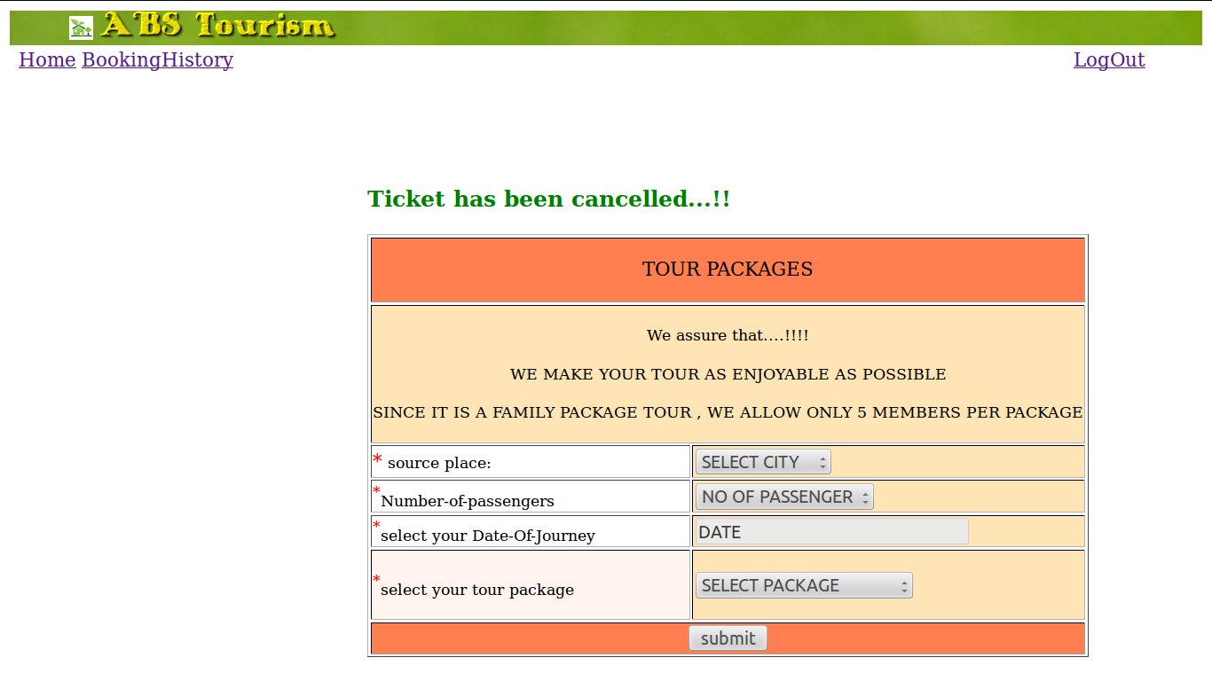

3. Users:
  - Administrator
  - Tourist

3.1 Administrator
The administrator has all the controls of the system. The administrator only can modify the tour package details, vehicle details and Hotel details and guide details. The administrator have separate login and also the user have separate login. Based on the login the control flow will be changed.

3.2 Tourist
Tourist have to register themselves with his personal details in registration module and authorized by the administrator. The tourist can access the system with limited permissions which is provided by the administrator and tourist need to log-out after each ticket booking . If the user stay idle for more than 15 minutes , then session will get expired
